Chapter 2 Atomic structure Revision name: class:
1.subatomic particles ( proton，neutron，electron) 的性质（charge，relative mass）
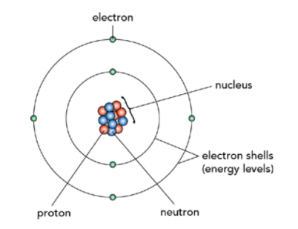
Subatomic particles: proton , neutron , electron
亚原子微粒 质子 中子 电子
Protons and neutrons are concentrated in the center of the atom (nucleus)
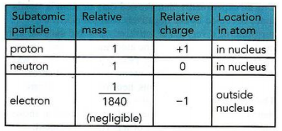

1. Which statements comparing the properties of electrons, neutrons and protons are correct? （ ）
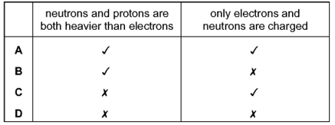

2. Which statement about atoms is correct? （ ）
A. Atoms contain protons and electrons in the nucleus.
B. Neutrons are negatively charged.
C. Protons are positively charged.
D. The nucleon number is the number of neutrons.
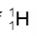
3 What do the nuclei of hydrogen atoms contain? （ ）
A electrons and neutrons
B electrons and protons
C neutrons only
D protons only
4. The table below gives the composition of six particles which are atoms or ions.
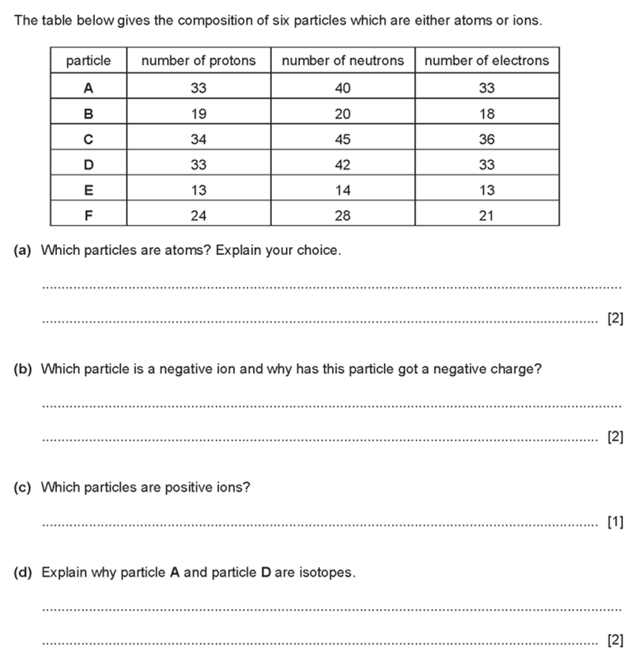
(a). Which particles are atoms? Explain your choice.

(b).Which particle is a negative ion and why has this particle got a negative charge?

(c).Which particles are positive ions?
(d).Explain why particle A and particle D are isotopes.

2.了解proton number and mass number的意义，并能根据给出微粒的proton number，mass number,shorthand symbol 判断微粒的subatomic particles的数量。

- Proton number(the atomic number): the number of protons of an atom
- Mass number( nucleon number ): is the total number of protons and neutrons in the nucleus of an atom. (Proton + neutron)
对于Atom来说： number of protons = number of electrons
Mass number = number of protons + neutrons

1. Element X is represented by
Which statement about element X is correct? （ ）
A An atom of X contains 13 protons and 13 neutrons.
B An atom of X contains 27 protons and 13 electrons.
C X forms an ion by gaining electrons.
D X is placed in Group III of the Periodic Table.

2. The diagram shows the structure of an atom of element X.
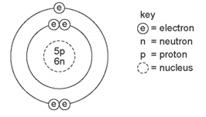
What is X? （ ）
A boron B carbon C sodium D sulfur
3. Which statements about a phosphorus atom, are correct ? （ ）
1 The nucleon number is 16.
2 The number of outer electrons is 5.
3 The proton number is 15.
A 1, 2 and 3 B 1 and 2 only C 1 and 3 only D 2 and 3 only

4. Which atom has twice as many neutrons as protons? （ ）
5. Which row gives the number of electrons in the outer electron shell of fluorine and of neon?（ ）
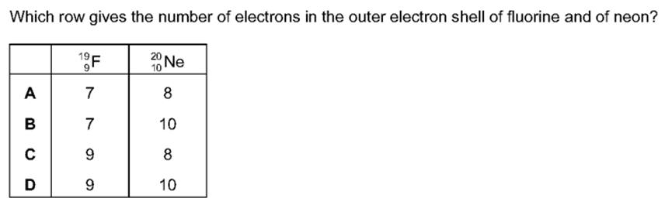

6. An atom has three electron shells. There are three electrons in the outer shell.
How many protons and how many neutrons are in this atom?（ ）
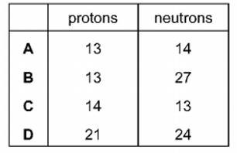
7. The table below gives the number of protons, neutrons and electrons in atoms or ions. Complete the table. The first line is given as an example.
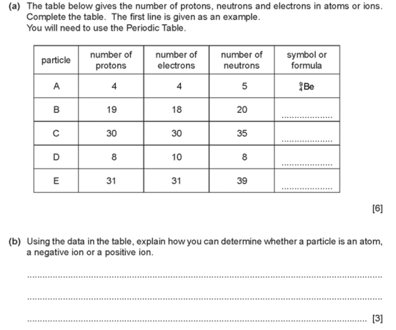
(b) Using the data in the table, explain how you can determine whether a particle is an atom,.a negative ion or a positive ion.

8. The table shows the composition of four atoms or ions, A, B, C and D
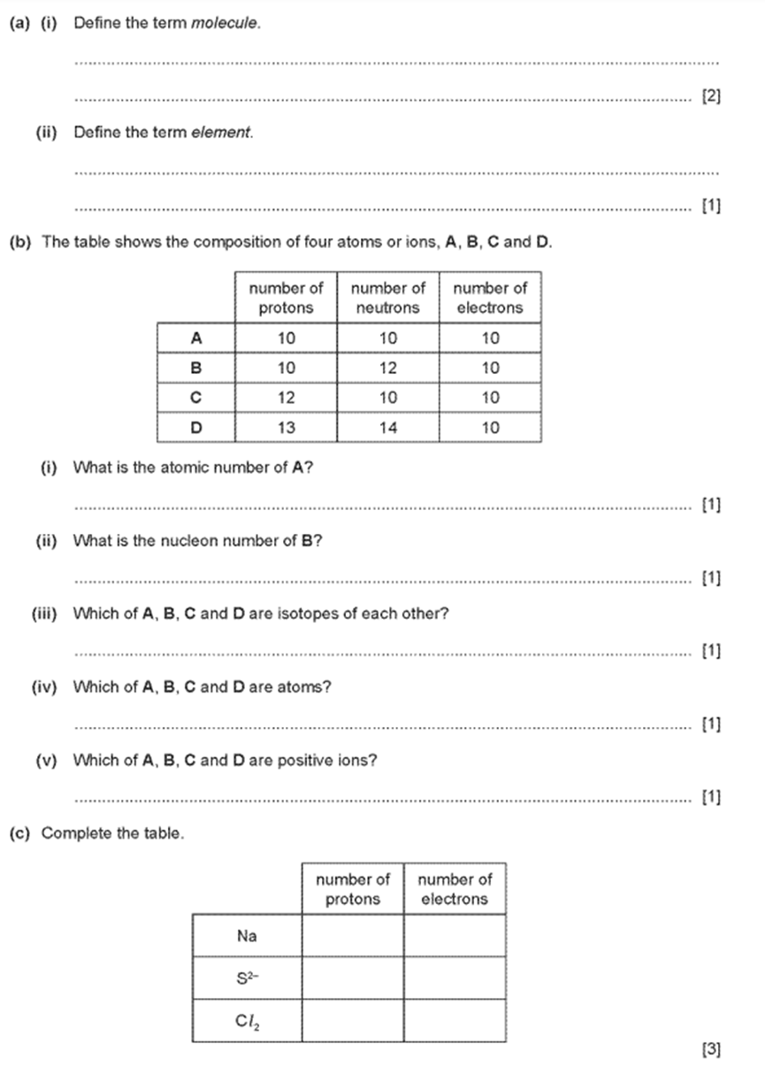

(i)What is the atomic number of A?
(ii)What is the nucieon number of B?

9. Complete the following table which gives the number of protons, electrons and neutrons in eachof the five particles.
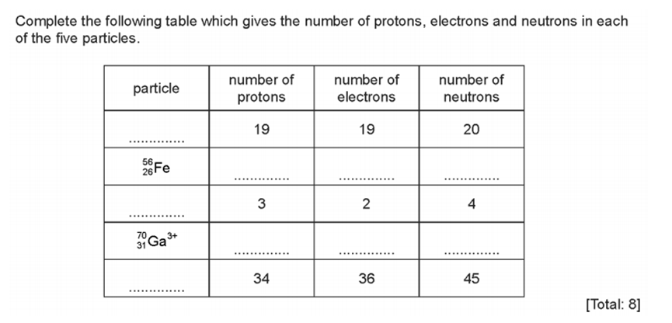
10. The table gives some information about four different particles, A, B, C and D.
(a) Complete the table. The first row has been done for you.
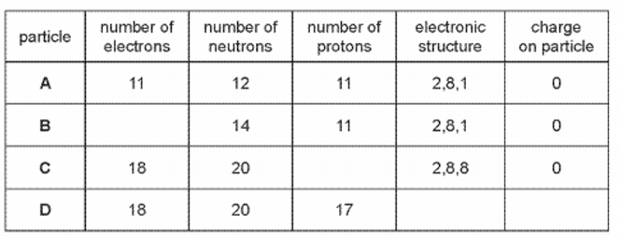

(b) Give two particles from the table which are isotopes of each other.

(c) Element Z is in the same group of the Periodic Table as A and has 2 electric shells.
State the identity of element Z.

(d) C is unreactive.
Use information from the table to explain why.

3. 了解nucleon number 的定义及其计算方法
nucleon number = mass number = number of neutrons + proton number
1. Atoms contain electrons, neutrons and protons.
What is the definition of nucleon number? （ ）
A the number of neutrons in the nucleus of an atom
B the number of protons in the nucleus of an atom
C the total number of neutrons and protons in the nucleus of an atom
D the total number of particles in an atom

2. (i) Define the term atomic number

(ii) Define the term nucleon number

3. The nucleon number of an isotope of rubidium is 85.
How many protons, neutrons and electrons are present in an atom of this isotope? （ ）
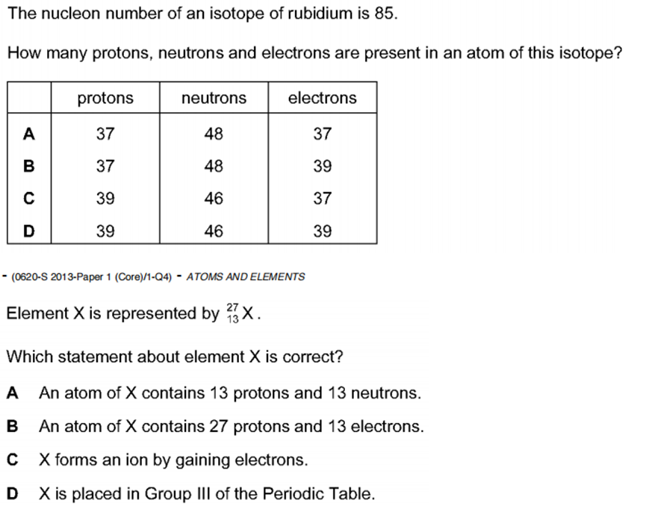
4. 掌握electronic structure 的排布方式，了解outer shell的定义，掌握outer electron shell 和outer electrons 对于元素周期表中Group and period 的关系。
Group : A vertical column in the periodic table of elements. (竖列）
Elements in the same group have same number of outer shell electrons.
在第几个group就有几个最外层电子。
Period :the horizontal row in the periodic table of elements. (横行）
The period number tells you how many electron shells are occupied
在第几个period就有几层电子层。

1. An element Y has the proton number 18.
The next element in the Periodic Table is an element Z.
Which statement is correct? （ ）
A Element Z has one more electron in its outer shell than element Y.
B Element Z has one more electron shell than element Y.
C Element Z is in the same group of the Periodic Table as element Y.
D Element Z is in the same period of the Periodic Table as element Y.

2. The diagram shows an atom of an element.
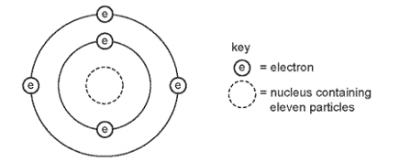
How many protons and neutrons are in the nucleus of the atom and in which group and period of the Periodic Table is the element found? （ ）
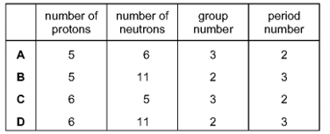

3. Element X has 7 protons.
Element Y has 8 more protons than X.
Which statement about element Y is correct? （ ）
A Y has more electron shells than X.
B Y has more electrons in its outer shell than X.
C Y is in a different group of the Periodic Table from X.
D Y is in the same period of the Periodic Table as X
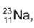
4. Which statements about a sodium atom, are correct? （ ）
1.The number of protons and neutrons is the same.
2.The number of protons and electrons is the same.
3. The number of outer electrons is one.
A. 1.2 and 3 B. 1 and 2 only C.1 and 3 only D. 2 and 3only

5. Argon, Ar, has a higher relative atomic mass than potassium, K, but appears before it in the Periodic Table.
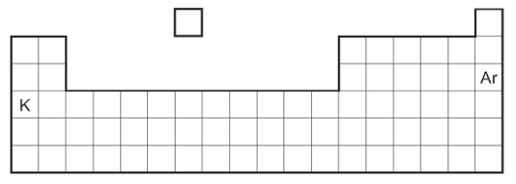
Why is argon listed before potassium in the Periodic Table?（ ）
A. Argon has fewer neutrons than potassium.
B. Argon has fewer protons than potassium.
C. Argon has more neutrons than potassium.
D. Argon has more protons than potassium.

6. Which element does not form a stable ion with the same electronic structure as argon? （ ）
A aluminium B chlorine C phosphorus D potassium

7. The electronic structures of some atoms and ions are shown.
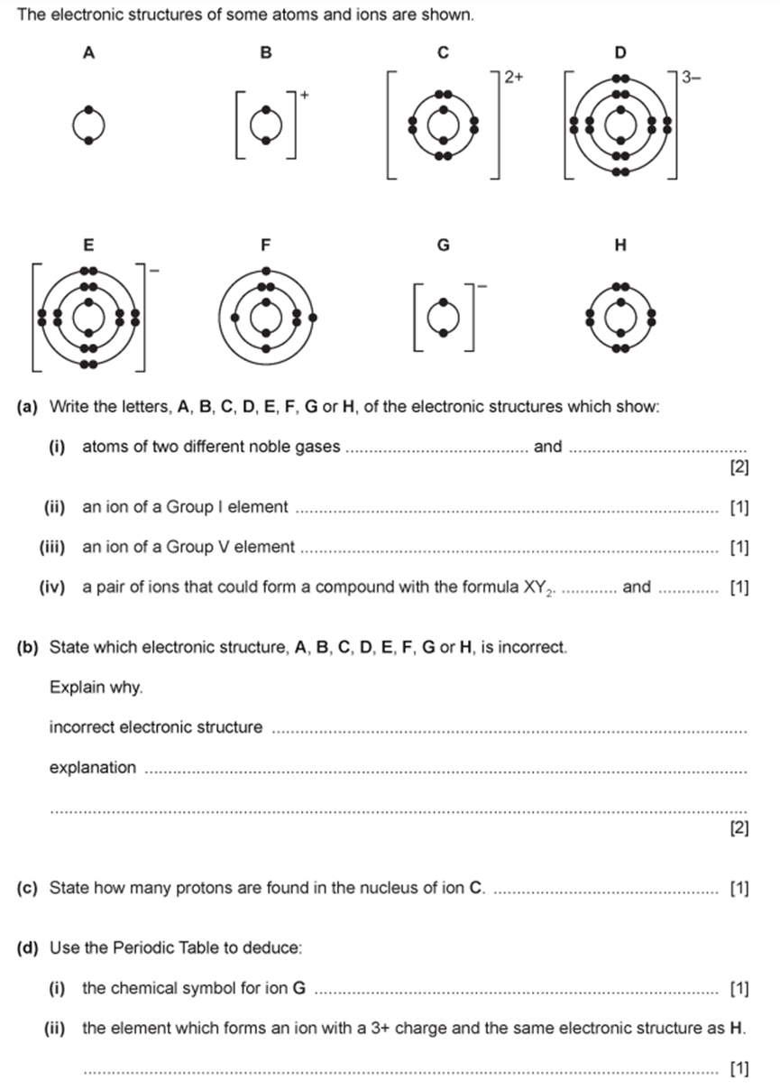
(a) Write the letters, A, B, C, D, E, F, G or H, of the electronic structures which show:
(i) atoms of two different noble gases ..............................and ................................
(ii) an ion of a Group I element ..............................................................................
(iii) an ion of a Group V element ..........................................................................
(iv) a pair of ions that could form a compound with the formula XY₂ .......... and ..........
(b) State which electronic structure, A, B, C, D, E, F, G or H, is incorrect.
Explain why.
incorrect electronic structure ..........................................................................
explanation .....................................................................................................................
........................................................................................................................................
(c) State how many protons are found in the nucleus of ion C. ..................................
(d) Use the Periodic Table to deduce:
(i) the chemical symbol for ion G ............................................................................
(ii) the element that forms an ion with a 3+ charge and same electronic structure as H.
......................................................................................................................................

5. 了解isotope的定义及其subatomic particles的数量差异；并掌握isotope在physical properties 和 chemical properties的异同。
Isotopes: the atoms of the same element that have the same number of protons, but different numbers of neutrons.（nucleon number）
Isotopes have different physical property → different number of nuetrons
Isotopes have same chemical property → same number of electrons

1. The nucleon number of an isotope of rubidium is 85.
How many protons, neutrons and electrons are present in an atom of this isotope?（ ）


2. The atomic structures of four atoms are shown.
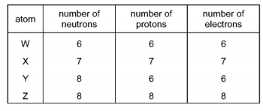
Which pair of atoms are isotopes? （ ）
A W and X B W and Y C X and Y D Y and Z

3. What is different for isotopes of the same element? （ ）
A. nucleon number
B. number of electron shells
C. number of electrons in the outer shell
D. proton number

4. The table shows the nucleon number and the number of neutrons in one atom of isotopes W, X,Y and Z.
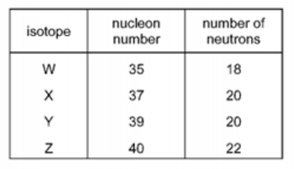
Which statement about W, X, Y and Z is correct? （ ）
A. W and X are isotopes of the same element.
B. X and Y are isotopes of elements in the same group of the Periodic Table.
C. Y and Z are isotopes of elements in the same period of the Periodic Table.
D. Z has a higher proton number than Y.

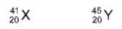
5. Two atoms, X and Y, can be represented as shown.
Which statement is not correct? （ ）
A X and Y are atoms of different elements.
B X and Y are isotopes.
C X and Y have different mass numbers.
D X and Y have the same number of electrons.

6.
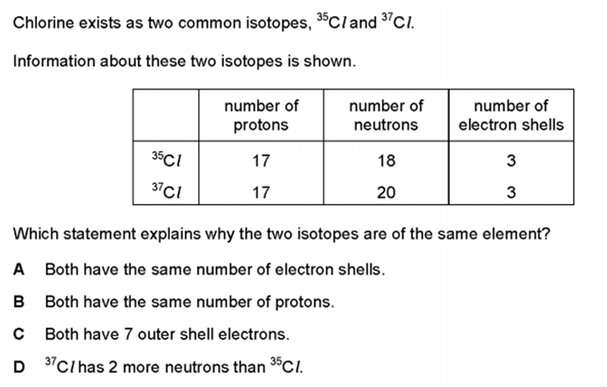

Which statement explains why the two isotopes are of the same element?（ ）
A. Both have the same number of electron shells.
B. Both have the same number of protons.
C. Both have 7 outer shell electrons.
D. ³⁷Cl has 2 more neutrons than ³⁵Cl.

7. Which statement explains why isotopes of the same element have the same chemical properties? （ ）
A They have a different number of neutrons in the nucleus.
B They have the same number of neutrons in the nucleus.
C They have the same number of outer shell electrons.
D They have the same number of protons as neutrons.

8. Which statement about the isotopes of an element is correct? （ ）
A Their physical properties are different because they have diferent proton numbers.
B. Their atomic masses are diferent because they have different numbers of electron shells.
C. They have the same chemical properties because they have the same number of electrons intheir outer shells.
D. They have the same physical properties because they have the same number of neutrons intheir nuclei.

